ME 4773/5493 Fundamental of Robotics
Fall 2016
San Antonio, TX, USA

Adaptive Control of a 2 degree of freedom Manipulator lifting a mass

Robert Brothers
Student Engineer
San Antonio, Tx, USA
rbrothers12@gmail.com

Abstract
Put abstract text here. Write this last, after you finish writing the full paper. Section 1 to 5. This should be a summary of your paper that talks about the problem and solution, results, and conclusion. It should provide enough details for someone to get a holistic understanding of your project.

- InTRODUCTION
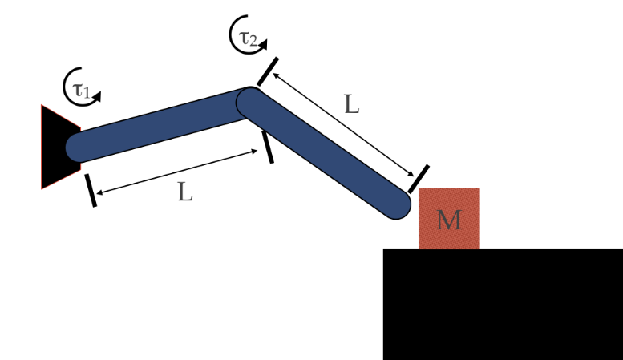
Previous research in the area of mechanics has shown that a 2-DOF manipulator, effectively double inverted pendulum, is a difficult problem for conventional control methods to solve reliably. This is due to its nonlinearities: Coriolis force, Potential Energies, and combined kinetic energies. In the project I demonstrate a similar system in which a double pendulum with motors at the joints is used to lift an object of unknown, but bounded, mass. In show this is a MIMO time invariant system because of the multiple torque inputs and the unchanging system parameters

Figure 1

For an adaptive controller this system, still no simple task solvable and will use less energy in its solution than would a conventional controller. To accomplish this I employ a Luenberger estimator to determine the mass of the object being lifted.
- Nomenclature
Put nomenclature here.

- METHODS
To develop the control method I begin by deriving the equations of motion using the Lagrangian Mechanics. To find the Lagrangian I use the DH convention. First assigning coordinate frame to each of the joints. Because they are both revolute the axis of action will be ‘z’ facing the user with the x-axis pointing next frame. The assignment of the y-axis is done using the right-hand rule. With the coordinate frame properly assigned the system can be reduced to the figure below and the DH parameters are as shown in the table below.
Link | A | Alpha | D | Theta
1 | L | 0 | 0 | Θ₁
2 | L | 0 | 0 | Θ₂
Using the values to determine the transformation matrices of each link. Contained in the Transformation matrix is a 3x3 orientation matrix and a 3x1 position vector which give the orientation of the link and the location of the next coordinate frame with respect to the current frame. For a rigid system like the proposed this is a very effective method of solving for the Jacobian. In solution of the Jacobian with respect to the center of mass which is symmetrically position at the center of the link I and able to use the Equation 1 to determine the Lagrangian.
$$L=T-V$$ | (1)

$$T=\frac{1}{2}*{\dot{q}}^{T}\left\{∑\left(m_{i}J_{vc-i}^{T}J_{vc-i}\right)\right\}*\dot{q}$$ | (2)

$$V=∑\left(M_{i}{\vec{g}}^{T}O_{cm-i}^{0}\right)$$ | (3)

After calculation of the Lagrangian I used Lagrange’s equations of the first kind with no Lagrange multipliers to determine the equations of motion.
$$\frac{∂L}{∂θ_{i}}-\frac{d}{dt}\left(\frac{∂L}{∂{\dot{θ}}_{i}}\right)=0$$ | (4)

Lagrange’s equation of the first kind give:
$$τ_{1}=-\ddot{θ_{1}}\left(2m_{2}L_{1}^{2}+m_{1}L_{1}^{2}\right)-g\left(\frac{m_{1}L_{1}}{2}+m_{2}L_{1}\right)sin⁡(θ_{i}$$ | (5)

$$τ_{2}=-\ddot{θ_{2}}\left(m_{2}{\dot{θ}}_{1}L_{1}L_{2}+\frac{m_{2}L_{2}^{2}}{2}\right)-{\ddot{θ}}_{1}m_{2}{\dot{θ}}_{2}L_{1}L_{2}-\frac{g\left(m_{2}L_{2}\right)}{2}\sin\left(θ_{2}\right)$$ | (6)

As the equations of motion. By inspection we can see there are multiple sources of nonlinearity. For the nonlinear parameters I will attempt to use a state observer to determine them in situ. To do this I will first need to determine whether or not the system is observable. To do this I will calculate the observability matrix as shown in the equation below.
$$τ_{2}=-\ddot{θ_{2}}\left(m_{2}{\dot{θ}}_{1}L_{1}L_{2}+\frac{m_{2}L_{2}^{2}}{2}\right)-{\ddot{θ}}_{1}m_{2}{\dot{θ}}_{2}L_{1}L_{2}-\frac{g\left(m_{2}L_{2}\right)}{2}\sin\left(θ_{2}\right)$$ | (7)

The system is observable IFF the matrix is full rank. In the event that the system is not completely observable I will need to attempt a reduced observability control scheme
employ the Luenberger State variable estimator or state observer to determine the “non-linear” state variables. But before we can employ an observer we must test the observability of the system. Because we know the linear portions of the state variable we can With a state estimator I expect to be able to determine the calculated the partial derivatives with respect to each of the characteristic variare the which contain the in the system to the Thoughout assigning coordinate frames to each of the joints the zeroth frame being in the Denavit-Hartenberg parameter to each of the joint-link combinations. For this system we have 2 revolute joints with / should be the.
- RESULTS
Write this part after you have written METHODS section. This will have all the results. The results should be in the form of tables, plots, and figures. These need to be explained.

- DISCUSSION
Write this part after you have written the RESULTS section. The motive of this section is to discuss the results in a broader context. The first paragraph can summarize the results. The next few paragraph should discuss the results. The final paragraph should present the limitations of your approach.

- Conclusion and FUTURE work
This is optional. Recommend to be written after you write DISCUSSION. A first paragraph can briefly summarize what was done, results and limitations and what is the main conclusion. A second paragraph can talk about how the work can be extended.

Acknowledgments
Put acknowledgments here.
References
[1] https://en.wikipedia.org/wiki/Lagrangian_mechanics

[2] Smith, J. (2015) Energy-efficient report writing, The Intl. Journal for diligent authors, 10(2), 1000-1021.

